Exercise Lab 09

Task#0: Why AVL? Explain in just two lines.
Given the BST (A and B) below, write a function to convert these BST into an AVL tree. The function should take the root of the BST as input and perform the conversion. Write only the conversion function, with no insertion logic needed. You may hard-code the given BST for this task.
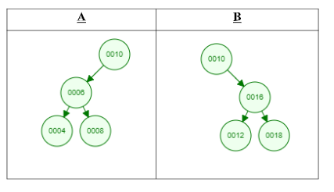
After converting the above BST to an AVL tree, explain each step of the code: how nodes are linked to form the AVL, the types of temporary pointers used in rotation functions, and how specific nodes (e.g., x, y, t2) correspond to the original tree nodes. Additionally, specify the type of rotation performed (right, left, or double rotation), and explain in 3-4 lines which node is returned at the end of the function and why.

Task#1: Suppose you are building an application that stores student records in an AVL tree based on their roll number. You want to insert a new student with roll number 15 into the AVL tree, and you want to ensure that the tree is balanced using left rotation. Assuming the AVL tree is already populated with the following student records:
Student 1 with roll number 10
Student 2 with roll number 20
Student 3 with roll number 30
Student 4 with roll number 40
Student 5 with roll number 50
- Walk me through the process of inserting the new student record with roll number 15 into the AVL tree.

- After inserting the new student record, what will be the height of the AVL tree?
- Using the left rotation operation, show the resulting AVL tree after inserting the new student record.

Task#2: Suppose you have an AVL tree with the following elements: 50, 30, 70, 20, 40, 60, 80. You need to insert a new node with value 55 into the tree and then display the tree after performing a left rotation on the root. Write a C++ code to accomplish this task using the AVLTree class and its methods.
Task#3: Suppose you have an AVL tree with the following nodes: 10, 5, 15, 3, and 7 (in this order). Perform the following steps:
- Insert the value 12 into the tree.
- Calculate the balance factor for each node.
- Check the height of the tree.
- If the tree becomes unbalanced during insertion, implement the rotations required to
- maintain balance.
- Provide the final balanced AVL tree.

Task#4: Find the kth smallest and largest value in the AVL tree and print its key also print both the left side and right side height of the tree starting from root.

